Move Workstation in AD Manually

Objective
Move a newly prepared device to the correct OU in Active Directory (BRA ▶ Workstations). Use this procedure when the endpoint is not applying group policies correctly or Administrator accounts are not working on the machine.

Step by Step
- Access the server USNPDCFGMGP02.na.contoso.com with '-PS' credentials.
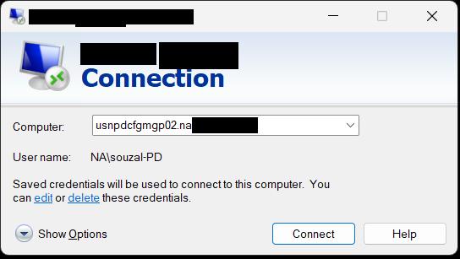
- Open Server Manager, go to Tools and open AD Users and Computers.
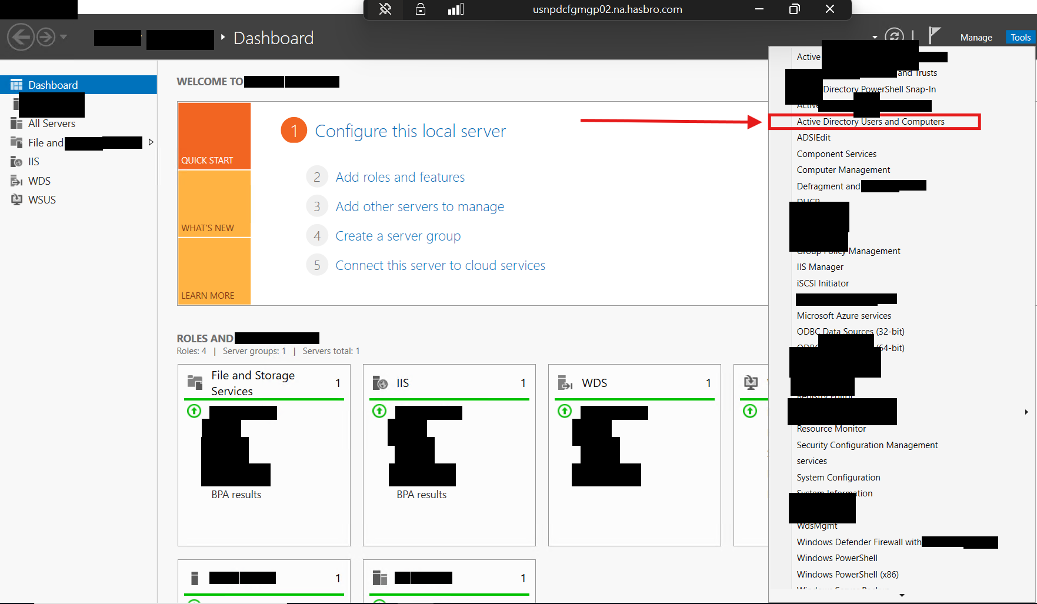
- In the na.contoso.com directory, open the 'Computers' container.
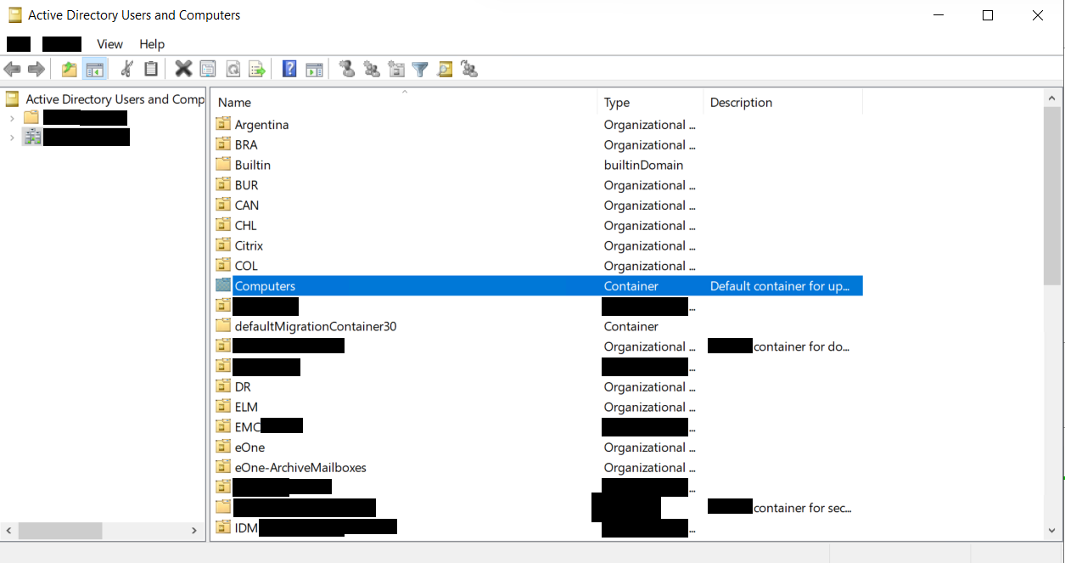
- Locate the target computer, right-click and select 'Move...'.
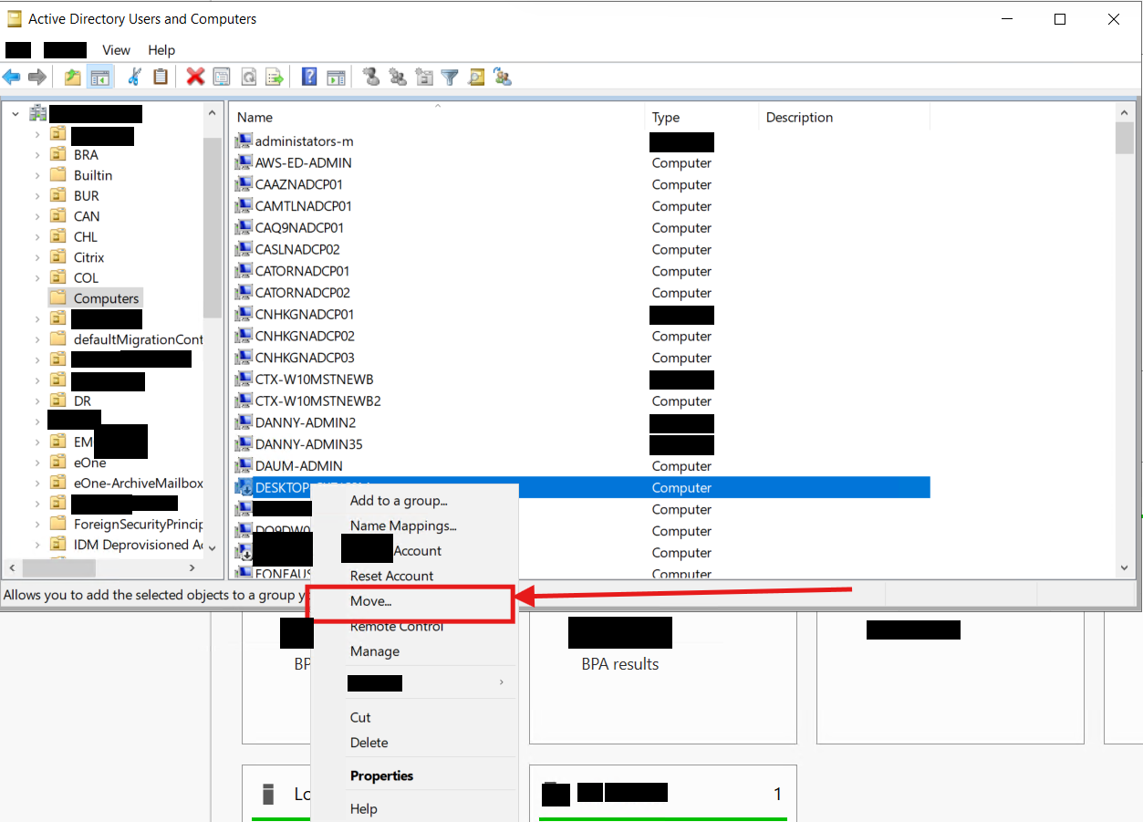
- Select the BRA > Workstations directory and click OK.
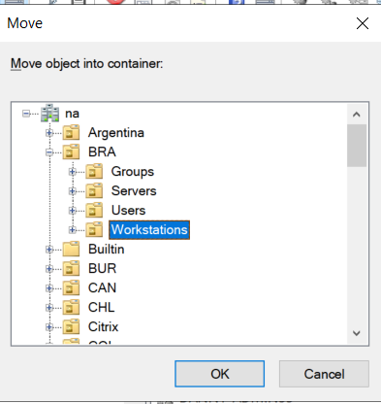
- After server synchronization (approx. 5-10 minutes), run Gpupdate /force on the target computer. The endpoint must be connected to VPN.

Version History
Author | Version | Date | Description
Lucas Souza | 1.0 | Aug/2026 | Document creation

